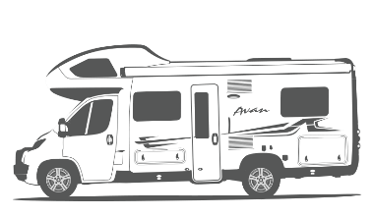

LILLEN CHECKLISTS

AND GUIDES

Contents

Checklists 2

Pre-Departure 2

On Arrival 3

Pre-Return 4

Bad Weather 4

What To Do 5

Accident 5

Breakdown 5

Dashboard Lights 5

Guides 6

Battery and Water Control Panel 6

Diesel Heater Control 7

Electric Bed 7

Step 1 - House Power Enabled 7

Step 2 - Electrical Cable Connectors 7

Step 3 - Fuse Box 7

Check 12V Power 7

Manual Operation 8

Hot Water Heater Controls 9

Electric 9

Gas 9

Nitrogen Tyre Inflation 9

Water Hoses and Power Cables 10

Drink Water Hose 10

Grey Water Hose 10

15A Extension Cable 10

Weatherproof Connector Protector 10

15A to 10A Power Adaptor 11

Storage 11

# Checklists

## Pre-Departure

Ensure that the rooftop tv antenna is retracted and secured

Ensure awning is retracted and secured properly

Ensure sunroof hatch is closed. Including in the bathroom

Ensure bike rack is secure

Ensure that Button 1-4 on the *Battery and Water Control Panel* are off

Ensure that the hot water heater is off

*Buttons are located on the left-hand side back lounge area*

Ensure that the diesel heater is off *if applicable*

*Dial is located on the left-hand side back lounge area*

Disconnect 240V electricity *if applicable*

Disconnect city water *if applicable*

Disconnect greywater *if applicable*

Ensure LPG gas bottles are turned off

Ensure that the windows are securely closed and locked

Ensure that the TV is locked away and secured

Ensure that the bunk bed safety net is connected

Ensure everything in the kitchen has been put away and is rattle-proof

Secure all drawers and doors

Secure all loose objects for travel

Ensure the table is in travel position

Start the engine for warm up

Ensure that the refrigerator (in auto mode) has shifted back 12V

## On Arrival

Select as flat and level a parking site as possible. Use leveling blocks if required.

Ensure the solar panels are not covered by shade as then they

will not charge the 12V battery properly.

Connect 240V electricity *if applicable*

*Check if* *15A to 10A Power Adaptor* *is required.*

Connect city water *if applicable*

Connect greywater *if applicable*

Ensure LPG gas bottle is open

Turn on button 1-3 on the *Battery and Water Control Panel*

Turn the water pump on, if not connected to city water  
*Button 4 on the Battery and Water Control Panel*

Turn the hot water heater on using either 240V or LPG gas.

Ensure the refrigerator (in auto mode) switch to either 240V or LPG gas.

If using LPG gas, turn the refrigerator fan on.

Ensure that the rooftop solar panels are not covered by shade.

**Please note!** If using LPG gas, it can take up **20 minutes** before the fridge turns on.

The refrigerator must be level and will not operate if not parked on a flat surface.

## Pre-Return

Full Tank of Diesel

Empty Toilet Cassette

Empty Greywater Tank

Interior Neat and Tidy

## Bad Weather

Before bad weather arises, please ensure the following:

Ensure awning is packed away

Ensure sunroof hatch is closed. Including in the bathroom

Ensure external storage hatches are closed

**Important!** Do not leave awning out overnight or unattended.

# What to Do

## Accident

The below instructions are from the official Camplify pre-hire checklist that is part of the handover.

1. Call Camplify on **1300 416 133** and inform them of the issue.
2. Take photos and send to the owner in case they need to raise a damage incident.
3. Inform the owner who, what, where and when the accident happened. If possible, use the messaging on Camplify's website.

## Breakdown

The below instructions are from the official Camplify pre-hire checklist that is part of the handover.

1. Get off the road, keep safe.
2. Call Camplify for NRMA Roadside on **1300 416 133** - select **option 4**.
3. The NRMA will help you get back on your journey or arrange alternatives.
4. Inform the owner what is happening. If possible, use the messaging on Camplify's
5. website.
6. Owner will make all decisions on where the van is towed and repaired.

## Dashboard Lights

The below instructions are from the official Camplify pre-hire checklist that is part of the handover.

1. Pull over immediately
2. Text the owner a photo of the dashboard and then call them immediately to get further instruction
3. If roadside assistance is required, call Camplify on **1300 416 133** and select **option 4** for road assistance

# Guides

## Battery and Water Control Panel

The Battery and Water Control Panel is located near the main door. As a rule of thumb, while stationary button 1-4 should be switched ON.

**Important!** All buttons must be switched **OFF** while driving.

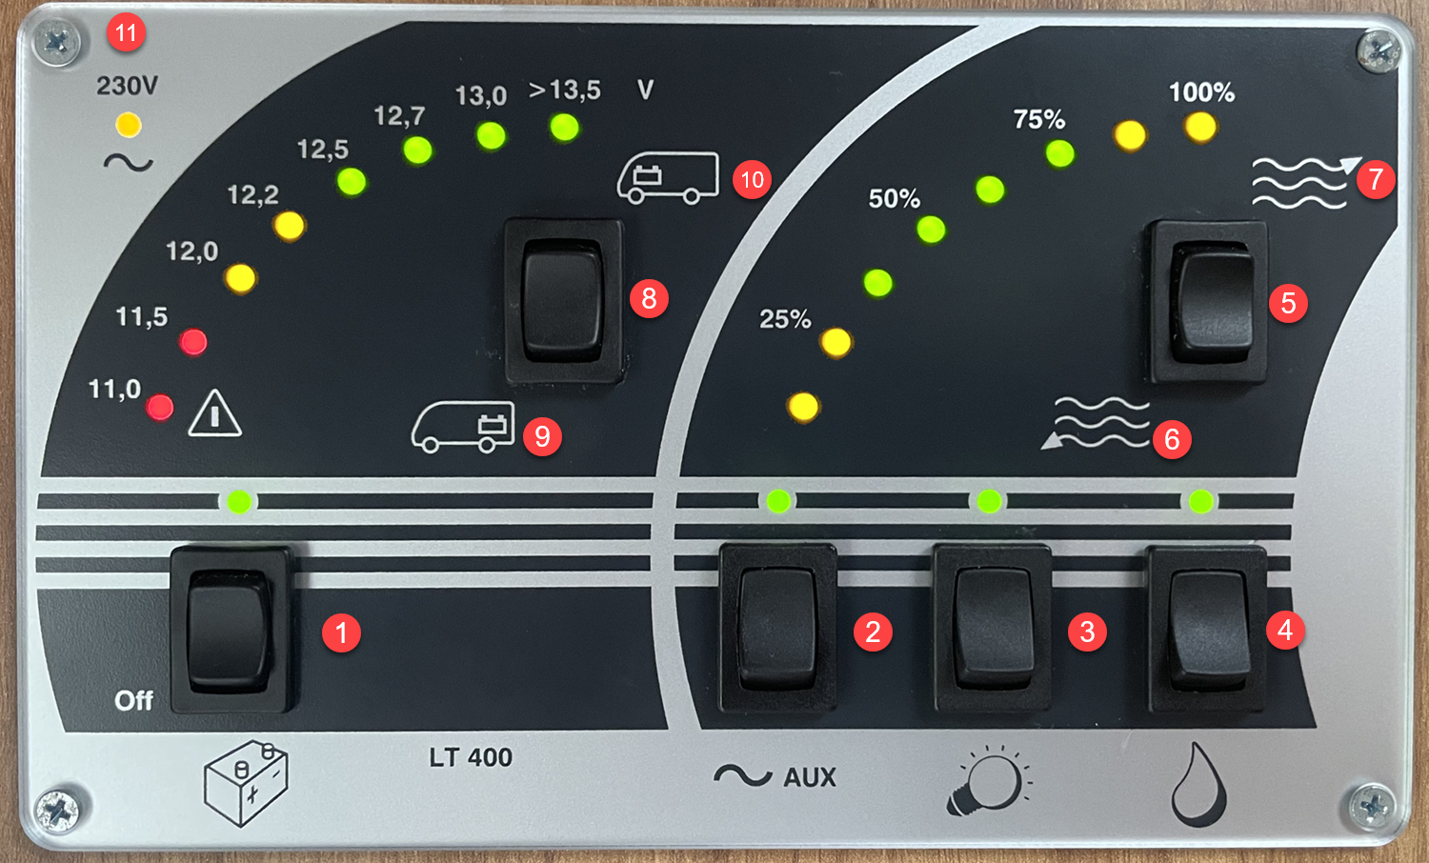

#### LEGEND

1. Main battery button
2. Turns on auxiliary power. (*Required for the powering the Bed, TV etc)*
3. Enables the lighting
4. Turns on the water pump *(Not required if connected to city water)*
5. Checks the water tank levels
6. Greywater tank
7. Fresh water tank
8. Check the 12V battery power levels
9. The house battery
10. The car battery
11. Light indicating that external 240V electricity is operational

## Diesel Heater Control

Lillen is equipped with a diesel heater for those cold winter months. It is using the same diesel fuel tank as the Fiat engine.

The diesel heater control is a dial that is located at the back of the motorhome on the left side next to the hot water heater controls.

To turn the heater on, simply turn the dial anti clockwise to the desired level.

Hot air will then blow out from under the wardrobe.

## Electric Bed

In the unfortunate event that the bed has stopped working please follow these 3 steps.

### Step 1 - House Power Enabled

First check that button 1 and 2 on the *Battery and Water Control Panel* are turned on.

### Step 2 - Electrical Cable Connectors

Second , check that the electrical cables that hang down on the inside of the storage hatch on the left rear side are properly connected. It’s easy to accidentally knock them out when removing the camping chairs and other large objects.

### Step 3 - Fuse Box

If the cables are properly connected, the next place to check is the fuse box that is located under the passenger couch behind the driver seat. There is a Spare Fuses Kit inside the storage hatch at the rear on the right side (where the water hoses are stored).

### Check 12V Power

If the bed will not raise when using 12V, check the power level of the "house battery" on

the *Battery and Water Control Panel*.

If the battery level is between 11.0 and 12.2 e.g red and amber lights, there might not be enough power to lift the bed back up.

Example of low power

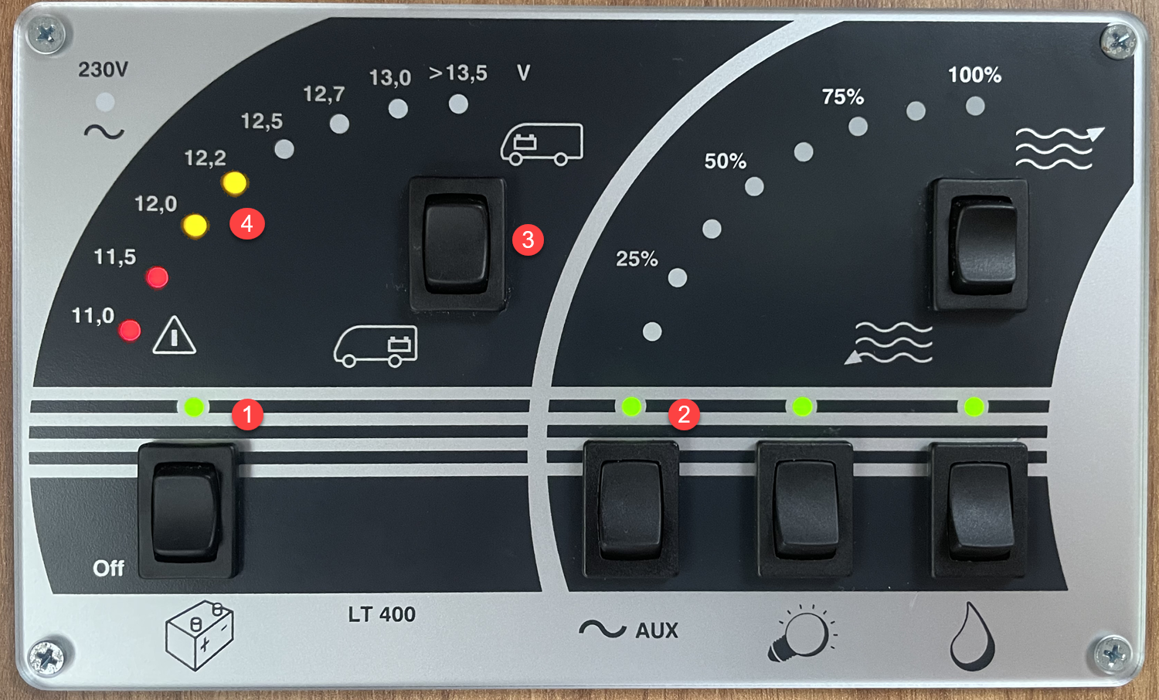

1. Ensure the battery indicator is lit green

2. Endure the AUX indicator is lit green

3. Press the battery switch down for House battery status

4. If the battery level is amber or red there might not be sufficient battery power left to raise the bed back up

#### Charge the 12V battery

Turn off anything that is not essential and wait for the solar panels to charge the battery.

Ensure that the rooftop solar panels are not covered by shade.

Alternatively, find a 240V power source (service station etc) using the 15A to 10A Power Adaptor if required and raise the bed whilst connected to external power.

### Manual Operation

According to the electric bed manual, there is an option for manual operation of the bed. It is a two-man job and it seem to be a complicated procedure.

**Important!** Do not attempt manual operation without first contacting the owner or Camplify support.

## Hot Water Heater Controls

The hot water controls are located at the back of the motorhome on the left side next to the diesel heater control.

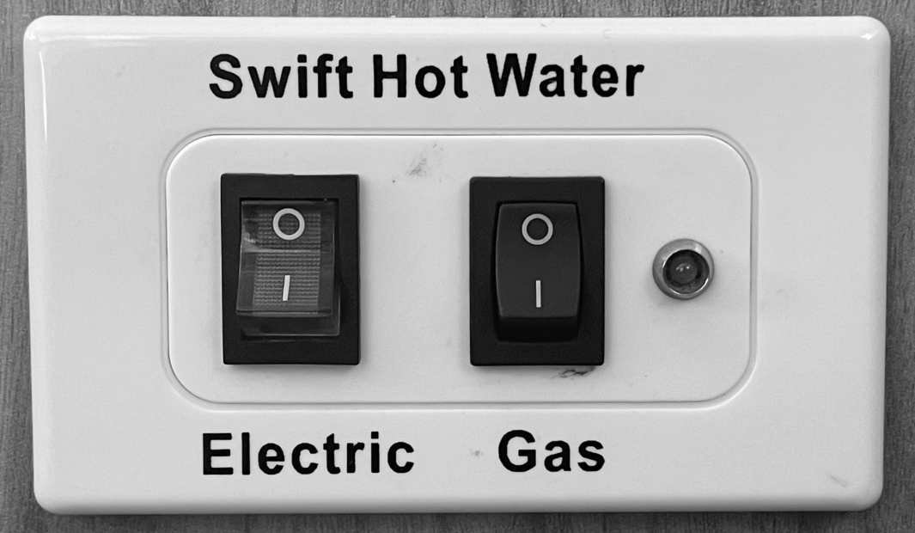

### Electric

When connected to 240V external power use the left electric button. The whole button is lit when the hot water heater is operating on 240V.

### Gas

If no access to external power, then use the right Gas button. The light to the right of the button indicates that the hot water heater is operating on LPG Gas.

## Nitrogen Tyre Inflation

Lillen's tyres have been inflated with nitrogen for increased tyre performance and better fuel economy.

This is identified by the red coloured valve cap.

If a top up is required and you are unable to find a workshop that offers nitrogen, air can be used but let the owner know upon return of the vehicle as the tyre will need to be fully deflated and refilled with nitrogen.

## Water Hoses and Power Cables

Lillen comes equipped with a drink water hose, grey water hose, a 15A extension cable and a 10A to 15A power adaptor.

### Drink Water Hose

The drink water hose is stored in a carrier bag together with a **12mm universal tap adaptor** (1).

Please use the **12mm two way coupling** to connect the hose ends as pictured below (2) prior to storage to prevent any residual water from leaking.

### Grey Water Hose

The grey water hose is stored in a carrier bag.

**Important!** Connect the hose ends as pictured below prior to storage to prevent any residual grey water from leaking.

### 15A Extension Cable

A 15 meter 15A Extension Cable is stored in a carrier bag together with a **Weatherproof Connector Protector** (1).

### Weatherproof Connector Protector

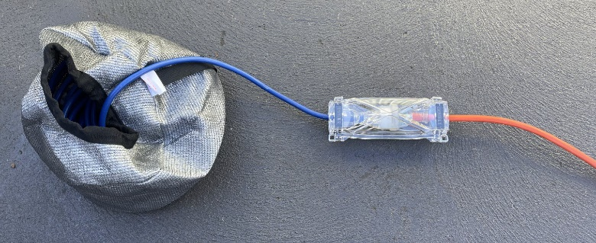If the extension cable is required, please use the weatherproof connector protector.

### 15A to 10A Power Adaptor

Use the included weatherproof 15A to 10A power adaptor to safely and legally connect the 15A power cable to 10A power point.

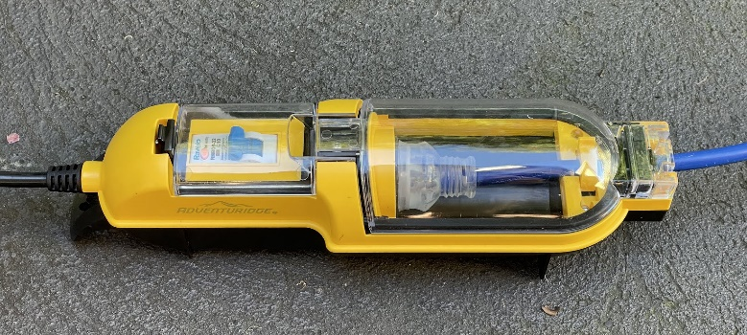

Generally, if you book a powered site at a caravan park it will be equipped with a 15A power point.

However, if you are taking Lillen to stay at someones property they might only have 10A power points.

### Storage

All water hose and power cable carrier bags are stored inside the right-side rear storage

compartment together with the weatherproof 15A to 10A power adaptor.

